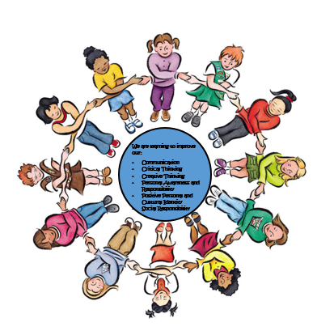
Reflecting on my Core Competencies
My Name is: ________________________________________________________
My Teacher(s): _________________________________________
School Year: _________________________________________________


Communication
I can ask questions.
I can answer questions.
I can be a good listener.
I can share my ideas.
I can take suggestions.
I can share my learning.
I can work with others.
I can give feedback to others.
Share how you are a Communicator:

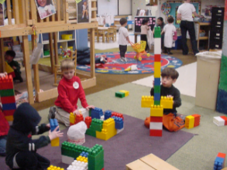
Critical Thinking
I can show if I like something or not.
I can explore using my five senses.
I can try new things.
I can ask questions to help me understand.
I can try different ways of doing things.
I can reflect on my thinking.
I can follow criteria.
I can tell the difference between reality and make-believe.
Share how you are a Critical Thinker:


Creative Thinking
I can get ideas when I play.
I can learn new ideas from others.
I can use my five senses to get ideas.
I can learn new things.
I have strategies that help me to be more creative.
I can change my ideas if they don't work.
I can keep trying to make my ideas work.
I can be interested in things.
Share how you are a Creative Thinker:

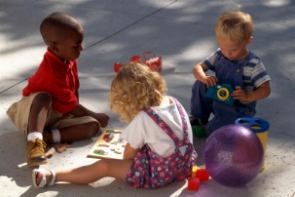
Personal Awareness and
Responsibility
I can celebrate when I do something well.
I can look out for myself.
I can look out for others.
I can make choices that help our world.
I can try to control my behaviour.
I can keep trying when something is hard.
I can set goals.
I can do things that help me to be healthy.
I can do things that help me to feel peaceful.
Share how you are Personally Aware and Responsible:


Personal and Cultural Identity
I can describe my family.
I can describe my community.
I can identify the groups that I belong to.
I can tell what is important to me.
I can describe who I am.
I can understand what makes me who I am.
I can describe what I am good at.
I can get better at things.
Share about your Personal and Cultural Identity:

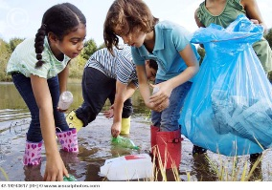
Social Responsibility
I can be part of a group.
I can help others.
I can solve my own problems.
I can ask for help.
I can say I am sorry.
I can forgive others.
I can be kind.
I can be respectful.
Share how you are Socially Responsible:

