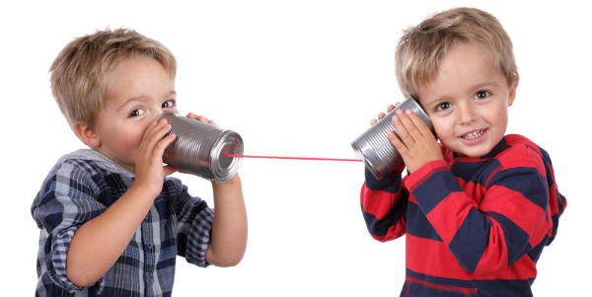
Communication
A communicator is someone who asks questions, listens thoughtfully, gives feedback, respects others' ideas, shows their learning, and shares information and ideas.
I can…  - I can tell someone about something I learned.  - I can ask questions.  - I can respond to questions.  - I am an active listener.  - I can tell someone what I think (give feedback).  - I can listen to people's ideas and make some changes.  - I can work with others and do my share. | Evidence:
 | My Next Steps:
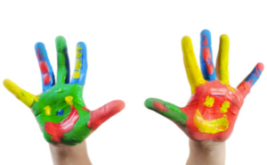
Creative Thinking
A creative thinker is someone who explores to come up with new ideas, builds on others' ideas, and uses these ideas to create something new.
I can…  - I can get ideas when I explore.  - I can build on the ideas of others.  - I can try different ways of doing things.  - I make my ideas work or I change what I am doing.  - I can follow my interests. | Evidence:
 | My Next Steps:
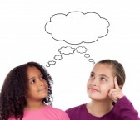
Critical Thinking
A critical thinker is someone who considers options, uses criteria, agrees or disagrees and uses evidence to explain why.
I can…  - I can explain why I like something or not.  - I can ask questions to learn more.  - I can try different ways of doing things.  - I can try to understand someone else's views.  - I can develop criteria.  - I can use criteria to make decisions.  - I can monitor my progress and choose my next steps. | Evidence:
 | My Next Steps:

Positive Personal & Cultural Identity
Someone who has a positive personal and cultural identity is aware of, understands, and appreciates who they are, where they come from, and what they can do to contribute to their own well-being and the well-being of others.
I can…  - I can tell what is important to me.  - I can describe my family and community.  - I can describe what I am like (my characteristics).  - I can tell what I am good at.  - I can tell how I can help others.  - I can tell what I want to get better at. | Evidence:
 | My Next Steps:
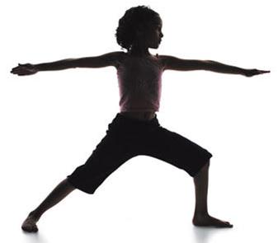
Personal Awareness and Responsibility
Someone who is personally aware and responsible is someone who sets goals and perseveres to meet them, demonstrates self-respect, and expresses a sense of personal well-being.
I can…  - I can set goals for my learning and behaviour.  - I can celebrate when I do something well.  - I can recognize my feelings.  - I can use strategies to help me feel peaceful.  - I can keep trying when something is hard.  - I can do things that help me be healthy. | Evidence:
 | My Next Steps:

Social Responsibility
Someone who is socially responsible contributes positively to their community and environment, empathizes with others, and creates and maintains healthy relationships.
I can…  - I can participate in classroom and group activities.  - I can solve some problems by myself and ask for help when I need it.  - I can tell someone how I feel if I am upset.  - I know when to say "I'm sorry."  - I can show respect and kindness to others, even if they are different.  - I can be a friend to others. | Evidence:
 | My Next Steps:

